CptS 543 Early Data Gathering Report

Yang Zhang, Samaneh Aminikhanghahi

March 20, 2017

## **Abstract**

We performed contextual inquiries to find out what are the key features that should be implemented in a social application which specially target at EECS graduate students. Knowing what graduate students mostly care about in both their academic and non-academic life are essential to design the graduate students social app. As a result of inquiries, we found that there are two kinds of academic goals that graduate students are after. One is to continue their academic career by applying post-doc programs or faculty positions. The other one is to find a job in industry world. From the above finding, we concluded that it is important to provide both job postings and academic program information to users of graduate students social app. In case of non-academic life, graduate students prefer to find other students or colleagues with same hobbies, schedule free time events and even ask questions. This defined the principal line in our design and other functions are discussed in the later part of this report.

## **Design project focus and research questions**

1. ***Design problem we aim to address***

We want to design a social application to not only provide a platform that allow EECS graduate student to post activities and exchange information with others but also help them in their career (jobs, or academic).

1. ***Proposed functions***
2. Account Management

Users can create a new account or close their existing accounts. They can also edit their account information and preferences.

1. Dashboard

Dashboard are composed by 3 categories, which are Academic, Career and Hobbies. In Academic, users can post academic questions and find out research opportunities and course info. In career, they can get recent job postings and grad school info (due dates, requirements) In Hobbies, they can post or join activities based on their interests and hobbies.

1. Search Function

User can search for public users, activities and other postings.

1. Message system

User can send public or private message to friends.

1. ***Related products or technologies***

[www.quora.com](http://www.quora.com) --- A question and answer site that users can post their question and receive answers from other users.

[www.linkedin.com](http://www.linkedin.com) --- LinkedIn is a business and employment-oriented social networking website

iStudiez Pro app --- An IOS app for prioritizing assignments/research and keeping track of schedule. iStudiez can sync with calendar, alert when there is a due, and help visualize student’s week.

Student Agenda app --- An android app designed to assist students in organizing their activities and have better performance.

1. ***Proposed software’s prospective users***

The prospective users for our application are current EECS graduate students.

1. ***Key research questions***

RQ1. How do graduate students search for jobs or academic programs?

RQ2. What tools do they use to post activities or questions and why do they choose them?

RQ3. What are their favorite features in social apps (Facebook, twitter, etc.)?

RQ4. What kind of information are grad students interested in.?

RQ5. What kind of topics are they mostly use when talk to other grad students?

## **Participants**

Participant 1 is a Computer Science graduate student at Washington State University. He is a first year PhD student, male and 33 years old. Participant 1 is very enthusiastic about social media, apps, and using technology in his daily life. Currently he is focusing mostly on courses and his research. He also likes to socialize and go to different kind of events.

Participant 2 is an Electrical engineering graduate student at Washington State University. He is a last year PhD student, male and 29 years old. Participant 2 is very enthusiastic about social media, apps, and using technology in his daily life. His first priority is finding job and deciding about his future career.

Participant 3 is a graduate student and she is Asian American female. After her graduation, she wants to work in an industry. She likes to use Twitter to follow her friends and other colleagues around world. She usually uses text message to arrange a study activity or review session.

## **Contextual Inquiry Sessions**

1. ***Process and Environment***

The contextual inquiries were conducted at artificial intelligence lab in EME building, WSU in one day. All three participants came to AI lab and after explaining the study to them, they signed consent forms. In the next step we had interviews.

In general, our participants were three people who were in different stage of their academic life. We asked each participant series of questions about their expectation from EECS grad app, and followed them throughout their use of social media and apps. Each session approximately lasted 30 minutes depending on their elaboration in responses. To see the set of questions asked, see Design project focus and research questions.

1. ***Common Tasks and Themes***

In general, all participants prefer the app keep update them about academic and future career opportunities such as job positions in both industry and academia, upcoming conferences, assignment deadlines, and recent researches. Also they would like to find new friends with similar hobbies and socialize in events and remind them with cultural and sport events.

Currently all participants are using different apps, social media websites, and professional websites for different purposes, but there is not a single tool which help them in all of the issues. Being intelligent and simple and not bothering members with too much information and notification are common expected features among all participants.

1. ***Unique features of individual CI sessions***

Not allowing strangers to send private message

Suggestion not only based on preference but also based on history

Having checklist for graduation

## **Synthesis of findings**

1. ***Requirements***

Table 1. Functional Requirements and Associated Usability Targets

|  |  |  |
| --- | --- | --- |
| Functional Requirement | Associated Usability Target(s) | Empirical Source/Rationale |
| Users must be able to create account and modify existing account | Users must be able to create account within 2 minutes | Participants wants the app to be fast and straight forward |
| Users must be able to specify or change their preferences | Users must be able to reach to preferences list less than 10 seconds. | Participants wants the app not to send irrelevant information |
| Users must be able to search among existing posts | Users must be able to reach the results of search within 5 seconds. | Participants wants the app to be fast |
| Users must be able to create activity for both academic and non-academic purpose | Users must be able to create activity less than 1 minutes. | Participants expect the app to help them for socialize |
| Users must be able to manage and track their courses progress | Users must be able to see the change or classes updates every day. | Participants expect the app to help them to keep track of their course works and assignments |
| Users must be able to send private and public messages to each other | Users must be able to reach their messages less than 10 seconds | Participants expect the app to help them for socialize |
| Users must be able not to receive messages from strangers | Users must be able to change setting of messengers within 10 seconds | Participants want to socialize with respect their privacy |
| Users must be able to find current activity or event post by other people | Users must be able to categorize existing activities based on keyword in less than 10 seconds | Participants expect the app to help them for socialize and finding friends |
| Users must be able to see upcoming conferences in their specified area | Users must be able to see updated conferences every week | Participants expect to be aware of new research opportunities |
| Users must be able to find new friends based on their similarities | Users must be able to search among existing users based on keywords less than 15 seconds | Participants expect the app to help them for socialize and finding friends |

Table 2. User Experience Requirements

|  |  |
| --- | --- |
| User Experience Requirement | Empirical Source/Rationale |
| Users must rate the app as 9 or higher on a scale of 1-10 in terms of ease of use | Participants wants the app to be straight forward and easy |
| Users must rate the app as 8 or higher on a scale of 1-10 in terms of being fast | Participants wants the app to be fast |
| Users must rate the information about graduate requirements and courses as 8 or higher on a scale of 1-10 in terms of being comprehensive and update | Participants wants the app to help them in their academic progress |
| Users must rate the app as 9 or higher on a scale of 1-10 in terms of being update on social and cultural events on campus | Participants expect the app to help them for socialize and finding friends |
| Users must rate the app as 9 or higher on a scale of 1-10 in terms of accuracy | Participants wants the app to help them in their academic progress and job hunting |
| Users must rate the app as 9 or higher on a scale of 1-10 in terms of being update on academic events and job opportunities | Participants wants the app to help them in their academic progress and job hunting |

1. ***Personas***

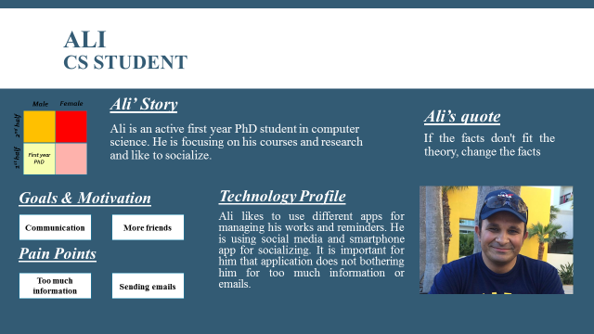

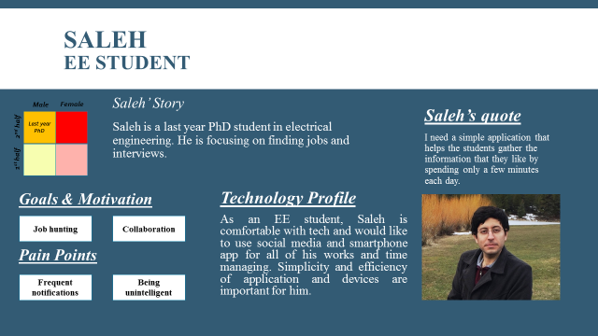

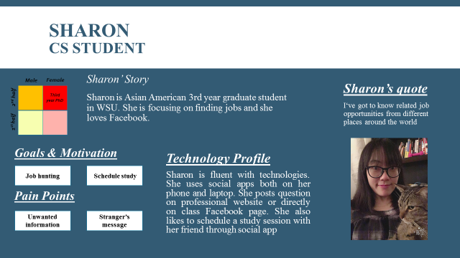

1. ***Scenarios***

*Scenario 1: What matters to Ali when playing disc golf*

Ali is a first year computer science graduate student at Washington State University. He likes to use EECS grad app to communicate with other students in both academic and non-academic life. He usually uses smartphone apps and website for all of his works and managements. Ali is comfortable using technology such as Facebook, google, calendars, notes to connect with other students and friends and manage his research and course works but he is frustrated about using different tools for different purpose and receiving too much information or notification.

Today Ali download a new EECS grad app and create an account for himself. He can specify his courses, research, and his other academic interests. Also he can select his hobbies and event types he like to attend. After choosing preferences, the app asks if he would like to receive reminders and notification about opportunities, other people questions, or events. Ali can answer for each category separately to not receive bothering emails and notifications.

*Scenario 2: What matters to Saleh when playing disc golf*

Saleh is a last year Electrical engineering graduate student at Washington State University. He likes to use EECS grad app to collaborate with other colleagues and knows about current job opportunities. He usually uses smartphone apps and website for all of his works and managements. Saleh is comfortable using technology such as LinkedIn, Facebook, and Indeed to search for job and current research but he is frustrated about how sometimes these websites suggest irrelevant jobs.

Today Saleh download a new EECS grad app and create an account for himself. He can specify his favorite job types and his skills. The app will search different job finding website and suggest related positions to Saleh. Saleh can rate the job opportunity that how relevant it is to his skills which makes the app more intelligent and more accurate in future suggestion. Also Saleh can search job opportunities among friends and other students post in related areas.

*Scenario 3: What matters to Sharon when playing disc golf*

Sharon is a 3rd year graduate student at Washington State University and she has only 1 year till her graduation. Finding a job is her priority thing to do in the rest of her academic life. On one Saturday, Sharon wake up at 9:30 AM. After having her breakfast, she turned on her laptop and logged in her LinkedIn account. There were two messages need her actions, one was to ask for her connection and the other one was to notify her a job status update from one of her friends. She accepted the connection request and talk to her friend about the job change. Then, Sharon opened account information, because she wants to update her experience section by adding a programming experience she just performed on this Wednesday. She also checked a few LinkedIn pages to see if there was any opening that match her skill sets. She began to study for her upcoming exam on Monday. There were certain topics that she didn’t understand thoroughly, so she was thinking about study with her friends. She opened Facebook on her phone and sent messages to her friends and then they decide to study together on Sunday. It was going to be another productive weekend for Sharon!

## **Appendix A: Informed Consent**

Informed Consent Agreement to Participate In

Contextual Inquiry

[Yang Zhang, Samaneh Aminikhanghahi]  
School of Electrical Engineering and Computer Science  
Washington State University

Description of Study:

The purpose of this study is for the designers to gather as much information about EECS graduate students and their expectation from an EECS graduate student app. This will help construct a clearer understanding of the unique needs required in terms of creating an application suited their academic and non-academic life. By doing this, the designers hope to create a more user-friendly application design for EECS graduate students.

Participation in Study:

I understand that I, _________________________________________ have been asked to participate in a contextual inquiry to inform the design of a new software application being created as part of the above persons’ (henceforth, “the designers”) course project for CptS 443/543 at Washington State University. My participation in this activity will help the designers to better understand the needs of prospective users of the software. I have been asked to spend about 30 minutes participating in this test. This will involve my engaging in using social media and smartphone applications while the designers observe, ask questions, and take notes.

Risks and Benefits Expected: The contextual inquiry will not do me any harm. It is not expected to help me directly. The results may help inform the design of the designers’ software.

Confidentiality: I understand that any information about me that is obtained from this contextual inquiry, including what I say, will be confidential. My real name will be kept in a locked file and only the researchers will have access to it. Only my code name will be associated with data collected on me. Reports and presentations involving those data will not use my real name, and will not present other data that could be used to identify me. Any recordings made within this contextual inquiry will be destroyed within two years.

Right to Refuse or End Participation: I understand that I may refuse to participate in this study or stop participating at any time.

Certification: I certify that I have read and that I understand the foregoing, that I have been given satisfactory answers to my inquiries concerning this contextual inquiry, and that I have been advised that I am free to withdraw my consent and to discontinue participation in the project or activity at any time.

I herewith give my consent to participate in this activity with the understanding that such consent does not waive any of my legal rights, nor does it release the researchers or any agent thereof from liability for negligence. I understand that I shall remain anonymous in all written and verbal reports of this study. If I am recorded, I agree to allow the designers to present to their instructor and classmates excerpts of any recordings taken during the study for educational purposes. I understand that I may request a copy of this form to keep.

Signature of individual participant Date

(If you cannot obtain satisfactory answers to your questions or have comments or complaints about your treatment in this activity, please contact Professor Christopher Hundhausen, Washington State University, 509-335-4590 or hundhaus@wsu.edu.)

## **Appendix B: Raw Data**

***Notes for Participant 1***

1. How do you as a graduate students search for jobs or academic programs?

* mostly using google for research interest and .edu domains
* for searching jobs using LinkedIn, cyber coders, monster

1. What tools do you use to post activities or questions and why do they choose them?

* Apple calendar
* Sticky notes
* Facebook events
* These are user friendly and free

1. What are your favorite features in social apps (Facebook, twitter, etc.)?

* Finding more friends
* Reading friend’s opinion

1. What kind of information are grad students interested in.?

* Any information helps them to progress such as jobs, conferences, new research
* Any information related to social event

1. What kind of topics are you mostly use when talk to other grad students?

* research
* new related papers
* courses and assignments
* sport events
* new movies
* campus events

1. What do you expect from an EECS grad app?

* Information about job opportunities, conferences, new researches
* do not sending too much information
* do not send emails
* being fast

***Notes for Participant 2***

1. How do you as a graduate students search for jobs or academic programs?

* There is no unique source for this type of information
* I look for jobs by tools such as LinkedIn, indeed, and similar websites
* In power systems area, most of academic positions are advertised in power globe website.
* Finding PhD positions is more difficult. We have to use university ranking websites (such as QS ranking and US news) to find appropriate universities, then browse their websites to see if there are active faculty in our area, and then contact the faculty one by one to see if there is any PhD position.

1. What tools do you use to post activities or questions and why do they choose them?

* I usually use LinkedIn. I believe LinkedIn posts are frequently viewed by other researchers. Also there are several specialized LinkedIn pages where people ask questions and get responses from other researchers in the field.

1. What are your favorite features in social apps (Facebook, twitter, etc.)?

* One feature of Facebook that I like is that it monitors all the posts that I read/like and then suggests the other posts that I might like (this feature does not work perfectly but it is getting better).
* A feature of LinkedIn that I like the most is that it suggests me some job openings that match my profile, and introduces people who know more about those openings and are potential contact persons.

1. What kind of information are grad students interested in.?

* Future events (e.g., IEEE events, conferences, talks, and social gatherings)
* Research activities of other students
* Available scholarships
* Available job openings

1. What kind of topics are you mostly use when talk to other grad students?

* Their progress toward graduation
* Their research activities and the possibility of a collaboration
* Topics related to school life, culture, politics, and economy

1. What do you expect from an EECS grad app?

* Something that helps the students share their activities, publications, and also post the future events.
* Something like a combination of Facebook and LinkedIn.
* Something simple that helps the students gather the information that they like by spending only a few minutes each day.

***Notes for Participant 3***

1. How do you as a graduate students search for jobs or academic programs?

* LinkedIn (connect with recruiter directly)
* Department emails (job posting)

1. What tools do you use to post activities or questions and why do they choose them?

* Post questions on class Facebook page.
* Reason: people in the group are from the same field
* Post question on vin.com (a website that every veterinarian around the world can share their knowledge)

1. What are your favorite features in social apps (Facebook, twitter, etc.)?

* Facebook, (most of her friends are using it, so she can keep in touch with her friends through it)

1. What kind of information are grad students interested in.?

* Job openings, the prospect of her major

1. What kind of topics are you mostly use when talk to other grad students?

* Study session
* Movies
* Academic subjects

1. What do you expect from an EECS grad app?

* Schedule Study session
* Movies recommendation
* Not allowing strangers to send messages